

MARMARA UNIVERSITY
FACULTY OF ENGINEERING
PHYS 1103.7
PHYSICS LABORATORY

EXPERIMENT 1
MEASUREMENTS, ERRORS AND GRAPHS
Section Number: 7
Group Number: 9
Submitted to: Arş. Göv. Hüseyin YALTIRIK
Due Date: 08.11.2021

 | Dept | Student Id | Name Surname | Contribution
1 | EEE | 150721062 | Muhammed Turhan ÇAKIR | Purpose, Theory, Calculations, Conclusion
2 | EEE | 150720062 | Mehmet Ali KAMALAK | Calculations, Conclusion. Theory
3

Table of Contents
1. PURPOSE 3
2. THEORY 3
A List of Materials 3
3. CALCULATIONS 4
Experiment-1 5
Experiment-2 7
4. CONCLUSION 9
5. REFERANCES 9

Table of Tables
Table 1: Measuring dimensions of the rectangular prism by ruler (cm). 5
Table 2: Measuring dimensions of the rectangular prism by caliper (mm). 5
Table 3: Calculations of the volume of the rectangular prism (cm³). 6
Table 4: Measuring density of the rectangular prism. 6
Table 5: Measuring dimensions of the cylinder by ruler (cm). 6
Table 6: Measuring dimensions of the cylinder by caliper (mm). 7
Table 7: Measuring density of the cylinder. 8

Table of Figures
Figure 1: Rectangular Prism 5
Figure 2: Cylinder 6

1. PURPOSE
In this experiment we aim to measure a rectangular prism’s and a cylinder prism’s dimensions with a ruler and a caliper. With the average of these measurements, we will calculate the volumes and densities of these objects with our devices uncertainty and find out the difference between our calculations.

2. THEORY
In this experiment, firstly, we are going to learn how to use a ruler and a caliper.
Ruler is a tool to measure lengths and draw straight lines and normally marked at regular intervals.
Caliper is a device to measure the dimensions of an object. It has less uncertainty than a ruler so the values you get with a caliper will be more accurate. In this experiment we will be using a vernier caliper.
We will use our tools to measure the dimensions of the objects and note them to our data sheet. Our steps will measure all three dimensions of our rectangular prism. Then we will calculate their volume and density using these data.
Volume is amount of space that a substance or an object occupies. For liquids however it is the amount of space that it occupies in a closed container.
Density of a substance is its mass per unit volume.
With given mass values, we will calculate the density of our objects using d =m/V. After calculating our values, we will compare them with each other.

A List of Materials
- A rectangular prism
- A cylinder
- Ruler
- Caliper
- A pencil
- Data Sheet

3. CALCULATIONS
In our experiment we did our calculations by taking the averages.

For volume calculations, we used: Δh for ruler is 0,5:
- ΔH = $\sqrt{{(\frac{dH}{H1}.Δa)}^{2} +{(\frac{dH}{H2}.Δb)}^{2} + {(\frac{dH}{H3}.Δc)}^{2}}$
- Δa= Δb= Δc=0.5 for ruler and $\frac{dH}{H1}$=$\frac{dH}{H2}$=$\frac{dH}{H3}$ = 1/3
- ΔH= $\sqrt{\left(\frac{1}{3}.0.5\right).3}$ = 0.3 for ruler
Δh for caliper is 0,01:
- ΔH = $\sqrt{{(\frac{dH}{H1}.Δa)}^{2} +{(\frac{dH}{H2}.Δb)}^{2} + {(\frac{dH}{H3}.Δc)}^{2}}$
- Δa= Δb= Δc= 0.01 in caliper and $\frac{dH}{H1}$=$\frac{dH}{H2}$=$\frac{dH}{H3}$ = 1/3
- ΔH= $\sqrt{\left(\frac{1}{3}.0.01\right).3}$ = 0.006 for caliper
For density calculations, we used:
- d = m/V
- %Δd = %d * d

Experiment-1

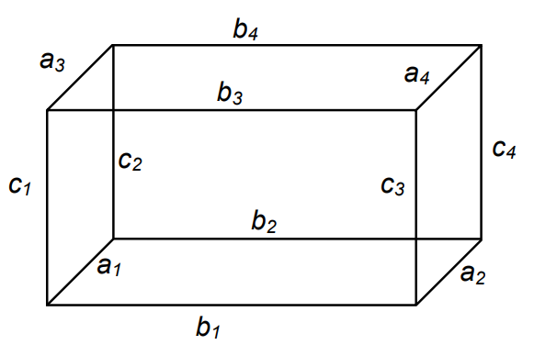
Figure 1: Rectangular Prism
Figure 1: Rectangular Prism

Data Table 1: Measuring dimensions of the rectangular prism by ruler (cm).
Table 1: Measuring dimensions of the rectangular prism by ruler (cm).
Data Number | a₁ ± Δa₁ | b₁ ± Δb₁ | c₁ ± Δ c₁
1 | 3,5 ± 0,5 | 5,45 ± 0,5 | 4,45 ± 0,5
2 | 3,5 ± 0,5 | 5,5 ± 0,5 | 4,5 ± 0,5
Average | 3,5 ± 0,5 | 5,475 ± 0,5 | 4,475 ± 0,5

Data Table 2: Measuring dimensions of the rectangular prism by caliper (mm).
Table 2: Measuring dimensions of the rectangular prism by caliper (mm).
Data Number | a₁ ± Δa₁ | b₁ ± Δb₁ | c₁ ± Δ c₁
1 | 34,8 ± 0,01 | 54,8 ± 0,01 | 44,8 ± 0,01
2 | 35 ± 0,01 | 55 ± 0,01 | 45 ± 0,01
Average | 34,9 ± 0,01 | 54,9 ± 0,01 | 49,5 ± 0,01

Data Table 3: Calculations of the volume of the rectangular prism (cm³).
Table 3: Calculations of the volume of the rectangular prism (cm³).
 | By Ruler | By Caliper
V ± ΔV | 85,75 ± 0,2 | 94,85 ± 0,0034

Data Table 4: Measuring density of the rectangular prism.
Table 4: Measuring density of the rectangular prism.
 | Mass (g) | Volume(cm³) | Density (g/cm³)
Volume With Ruler | 123 ± 0,5 | 85,75 ± 0,2 | 1.44 ± 0,0086 g/cm³
Volume With Caliper | 123 ± 0,5 | 94,85 ± 0,0034 | 1,29 ± 0,005 g/cm³

Ruler:
m = 123 ± 0,5 g and V = 85,75 ± 0,2 cm³
d = 123 g / 85,75 cm³ = 1.44 g/cm³
%d = 0,5/123 + 0,2/85,75 = 0,006
%Δd = 0,006 * 1,44 g/cm³ = 0,0086 g/cm³

Caliper:
m = 123 ± 0,5 g and V = 94,85 ± 0,0034 cm³
d = 123 g / 94,85 cm³ = 1,29 g/cm³
%d = 0,5/123 + 0,0034/94,85 = 0,004
%Δd = 0,004 * 1,29 g/cm³ = 0,005 g/cm³

Experiment-2

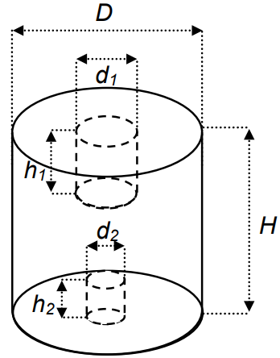
Figure 2: Cylinder
Figure 2: Cylinder

Data Table 5: Measuring dimensions of the cylinder by ruler (cm).
Table 5: Measuring dimensions of the cylinder by ruler (cm).
Data Number | D ± ΔD | H ± ΔH | d₁ ± Δd₁ | h₁ ± Δh₁ | d₂ ± Δd₂ | h₂ ± Δh₂
1 | 4,45 ± 0,5 | 5,95 ± 0,5 | 1,30 ± 0,5 | 2,10 ± 0,5 | 0,95 ± 0,5 | 1,30 ± 0,5
2 | 4,5 ± 0,5 | 5,85 ± 0,5 | 1,30 ± 0,5 | 2,0 ± 0,5 | 0,90 ± 0,5 | 1,20 ± 0,5
Average | 4,475 ± 0,5 | 5,90 ± 0,5 | 1,30 ± 0,5 | 2,05 ± 0,5 | 0,925 ± 0,5 | 1,25 ± 0,5

From the data Table-5
V ± ΔV= 92,79 ± 0,2 cm³ (volume of the cylinder without the hole)

V ± ΔV= 2.721 ± 0,2 cm³ (volume of the first hole)

V ± ΔV= 0.840 ± 0,2 cm³ (volume of the second hole)

V ± ΔV= 89,23 ± 0,2 cm³ (volume of the cylinder)

Data Table 6: Measuring dimensions of the cylinder by caliper (mm).
Table 6: Measuring dimensions of the cylinder by caliper (mm).
Data Number | D ± ΔD | H ± ΔH | d₁ ± Δd₁ | h₁ ± Δh₁ | d₂ ± Δd₂ | h₂ ± Δh₂
1 | 44,8 ± 0,01 | 60 ± 0,01 | 13,0 ± 0,01 | 20,0 ± 0,01 | 8,6 ± 0,01 | 11,8 ± 0,01
2 | 45 ± 0,01 | 61 ± 0,01 | 12,0 ± 0,01 | 20,0 ± 0,01 | 8,8 ± 0,01 | 12,0 ± 0,01
Average | 44,9 ± 0,5 | 61,5 ± 0,01 | 12,5 ± 0,01 | 20,0 ± 0,01 | 8,7 ± 0,01 | 11,9 ± 0,01

From the data Table-6
V ± ΔV= 97374,422 ± 0,006 mm³ = 2,454 ± 0,06 cm³ (volume of the cylinder without the hole)

V ± ΔV= 2454,297 ± 0,006 mm³ = 2,454 ± 0,06 cm³ (volume of the first hole)

V ± ΔV= 707,396 ± 0,006 mm³ = 0,707 ± 0,06 cm³ (volume of the second hole)

V ± ΔV= 94212,7 ± 0,006 mm³ = 94,212 ±0,06 cm³ (volume of the cylinder)

Data Table 7: Measuring density of the cylinder.
Table 7: Measuring density of the cylinder.
 | Mass (g) | Volume(cm³) | Density (g/cm³)
With Ruler | 161 ± 0,5 g | 89,23 ± 0,2 cm³ | 1.8 ± 0,009 g/cm³
With Caliper | 161 ± 0,5 g | 94,212 ±0,06 cm³ | 1,70 ± 0,005 g/cm³
Ruler:
m = 161 ± 0,5 g and V = 89,23 ± 0,2 cm³
d = 161 g / 89,23 cm³ = 1.8 g/cm³
%d = 0,5/161 + 0,2/89,23 = 0,005
%Δd = 0,005 * 1,8 g/cm³ = 0,009 g/cm³
Caliper:
m = 161 ± 0,5 g and V = 94,212 ± 0,06 cm³
d = 161 g / 94,212 cm³ = 1,70 g/cm³
%d = 0,5/161 + 0,06/94,212 = 0,003
%Δd = 0,003 * 1,70 g/cm³ = 0,005 g/cm³

4. CONCLUSION
In this experiment, we learnt how to use a vernier caliper and a ruler.
In our first experiment we measured our rectangular prism’s dimensions. We calculated the average of our values and with these average values we calculated our objects volume with an uncertainty.
In our second experiment we measured cylinder’s height, diameter and holes’ diameter and height with a ruler and a caliper, and we noted them on tables. With the averages of these measurements, we calculated our cylinder’s volume with and without holes.
Then, using our values and with given masses of the objects we calculated their densities. When we checked and compared our density and volume values, we have come to a conclusion that the measurements which we made with a caliper is more precise than the measurements we made with a ruler.

5. REFERANCES
https://en.wikipedia.org/wiki/Calipers
https://www.merriam-webster.com/dictionary/intensity
https://www.merriam-webster.com/dictionary/volume



